An Intelligent Approach for Deepfake Detection

Dr. Pardeep Kumar
Artificial Intelligence and Machine Learning
Anurag University
Hyderabad, India
pardeepsep2@gmail.com
Ganne Uday Kiran
Artificial Intelligence and Machine Learning
Anurag University
Hyderabad, India
udaykiranganne015@gmail.com
Palla Pragyna
Artificial Intelligence and Machine Learning
Anurag University
Hyderabad, India
pallapragyna@gmail.com
Gunimini Sathvik Reddy
Artificial Intelligence and Machine Learning
Anurag University
Hyderabad, India
Guniminisathvik6@gmail.com

Abstract— Deepfake technology is advancing very fast, and it is becoming quite difficult to trust digital images and videos shared on different platforms. Deepfakes are artificially created or modified media using advanced artificial intelligence techniques, which often look very real. Though such content may be very convincing, it can also be very misleading and is often misused for various malicious purposes such as spreading misinformation, generating fake identities, affecting public opinion, and causing harm to individuals or organizations. Therefore, detecting deepfakes has become a very important problem to solve for ensuring the security of digital media. In this work, we present a deep learning-based method for detecting deepfake images and videos. The proposed model is designed to automatically distinguish between real and fake media using the EfficientNetB0 architecture. For image detection, the model learns discriminative features from the dataset, while for video detection, frames are extracted and analysed individually to identify manipulation patterns. The final prediction for videos is obtained using frame aggregation techniques. To improve the performance and generalization ability of the model, appropriate data preprocessing and augmentation techniques are applied. The approach focuses on selecting suitable input representations such as resized and normalized images and video frames. Since deepfakes often contain subtle spatial inconsistencies and frame-level artifacts, the model is trained to capture these features effectively across both images and videos.
Keywords— Deepfake Detection, Convolutional Neural Networks, EfficientNet, Transfer Learning, Video Frame Aggregation, Digital Forensics, Computer Vision, Media Authentication.

Introduction
In recent years, the rapid advancement of artificial intelligence has led to the development of highly realistic synthetic media, commonly known as deepfakes. These are digitally manipulated images or videos in which a person’s face or actions are altered using deep learning techniques, often making it difficult to distinguish between real and fake content. While deepfake technology has useful applications in entertainment, filmmaking, and virtual reality, it also raises serious concerns related to misinformation, identity theft, and digital security. The misuse of such technology can have significant social, political, and economic consequences, making the detection of deepfake content an important research problem.
Traditional methods of detecting manipulated media relied on manual inspection or basic image processing techniques. However, these approaches are often time consuming, subjective, and ineffective against modern deepfake generation methods, which are becoming increasingly sophisticated. With the rise of advanced generative models such as Generative Adversarial Networks, deepfakes have become more realistic, further increasing the need for automated and reliable detection models.
To address these challenges, researchers have increasingly turned to deep learning and computer vision techniques for detecting deepfake content. Convolutional Neural Networks have proven to be particularly effective in extracting meaningful features from images and identifying subtle inconsistencies that may not be visible to the human eye. In addition, transfer learning has enabled the use of pretrained models, allowing faster training and improved performance even with limited datasets.
This paper proposes a deep learning based model for detecting deepfake content in both images and videos. For image detection, a pretrained EfficientNetB0 model is used due to its efficiency and strong performance in image classification tasks. The model is fine tuned to classify images as real or fake by learning discriminative features from the dataset. Data augmentation techniques such as rotation, flipping, and brightness adjustment are applied to improve the model’s ability to generalize across different conditions.
For video detection, the proposed model adopts a frame based approach. Instead of processing entire videos directly, frames are extracted at regular intervals and individually analysed using the trained image model. The predictions obtained from each frame are then aggregated to determine the final classification of the video. This approach simplifies the problem while still capturing important temporal information. By averaging the predictions across multiple frames, the model reduces the impact of noise and improves overall accuracy.
The proposed method offers several advantages. It combines both spatial analysis for images and temporal approximation for videos, making it a unified solution for deepfake detection. Additionally, the use of transfer learning reduces computational complexity and training time, while still achieving high accuracy. The model is also scalable and can be integrated into real world applications such as social media monitoring, digital forensics, and cybersecurity systems.

Despite its effectiveness, the proposed approach has certain limitations. The frame based video analysis does not fully capture temporal dependencies between consecutive frames. Future work can address this by incorporating sequence based models such as Long Short-Term Memory networks or 3D convolutional neural networks to better model temporal patterns in videos.
In conclusion, this work contributes to the growing field of deepfake detection by providing an efficient and practical solution for identifying manipulated images and videos. The results demonstrate that deep learning based approaches can play a crucial role in ensuring the authenticity and reliability of digital media in today’s increasingly AI driven world.

Related work
Several studies have explored the application of deep learning and computer vision techniques for detecting deepfake images and videos, driven by the rapid advancement of synthetic media generation. These approaches aim to identify subtle artifacts and inconsistencies introduced during manipulation.
M. Alrashoud (2025) presented a comprehensive overview of deepfake video detection methods, including convolutional neural networks, frequency domain analysis, and audio visual synchronization techniques. The study emphasized the importance of multi modal detection for improving robustness. However, it also highlighted a key limitation, where model performance tends to degrade significantly when dealing with compressed or low quality videos.
H. Kim (2025) proposed a novel deep learning based facial forgery detection approach using texture based convolutional neural networks combined with supervised contrastive learning. The method demonstrated robustness against data imbalance and effectively captured high frequency texture features. Despite these advantages, the model was evaluated on limited datasets, which may affect its ability to generalize to diverse real world scenarios.
Gong and Li (2024) conducted a comprehensive survey on deepfake detection, covering a wide range of datasets and algorithms such as CNN, Vision Transformers, and capsule networks. Their work provided a structured understanding of existing techniques but pointed out challenges such as reduced cross dataset performance and limited focus on real time implementation.
Similarly, A. Kaur et al. (2024) analysed various deepfake detection approaches, including CNN based, transformer based, and biological signal based methods. While their study offered valuable insights into existing challenges and datasets, it did not propose a new detection framework.
Furthermore, Lv et al. (2024) introduced Domain Forensics, a method based on Vision Transformers and domain adaptation techniques to improve cross domain detection. Although the approach showed improved performance in detecting unseen forgeries, it involved high computational cost and a complex training process.

Methodology

A.Data Collection
For this study, deepfake images were obtained from the Manjilkarki dataset, while deepfake videos were collected from a dataset provided by Sanika Tiwa Rekar on Kaggle. Both datasets consist of labelled samples categorized as Real and Fake, making them suitable for training and evaluating a binary classification model.

B.Image Preprocessing
The collected images vary in size and quality. To ensure consistency and improve model performance, the following preprocessing steps were applied:
- All images were resized to a fixed dimension of 256 × 256 pixels
    - $I_{resized}$= resize(I, 256, 256)
- Pixel values were normalized using EfficientNet preprocessing
  - $I_{norm}=$ preprocess($I_{resized})$

- Data augmentation techniques such as rotation, zooming, horizontal flipping, and brightness adjustment were applied to increase dataset diversity and prevent overfitting.

C. Feature Extraction:
- Feature extraction is performed automatically using a deep learning model instead of manual methods. A pretrained EfficientNetB0 model is used to extract meaningful features from the input images.
- The convolutional layers of the network capture important visual patterns such as texture inconsistencies, edge distortions, and facial artifacts that are commonly present in deepfake media.
- F = CNN($I_{norm})$
- Global Average Pooling is applied to reduce the dimensionality of the extracted features:

$F_{gap}=GAP(F)$

D. Classification:
The extracted features are passed through fully connected layers for classification:
- Dense layer with ReLU activation
- Dropout layer (0.5) to reduce overfitting
- Output layer with Sigmoid activation for binary classification
  - Y = σ(W. $F_{gap}+b)$
The model is trained using:
- Loss Function: Binary Cross entropy
- Optimizer: Adam

E. Video Processing:
For deepfake video detection, a frame-based approach is adopted.
- Frame Extraction: Each video is divided into multiple frames at regular intervals:
- Frames = extract(video, N=20)
- Frame Classification: Each extracted frame is passed through the trained image model:
- $p_{i}=Model({Frame}_{i})$
- Aggregation: The final prediction for the video is obtained by averaging the predictions of all frames:
- $P_{video}= \frac{1}{N}\sum_{i=1}^{N}{p_{i}}$
- If $P_{video} ≥0.6→Fake$
- Else $→Real$

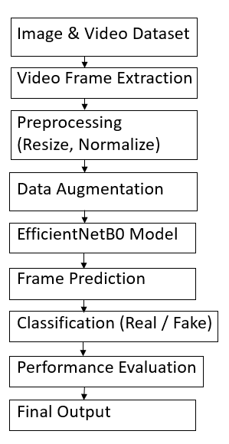
Fig.1. Proposed Methodology

Dataset
For this study, deepfake images were obtained from the Manjilkarki dataset, while deepfake videos were sourced from a dataset provided by Sanika Tiwa Rekar on Kaggle. Both datasets include labelled real and fake samples, enabling effective training and evaluation of the proposed deep learning based deepfake detection models.
Table1: Details of the Dataset
S.no | Dataset Type | Category | Number of Samples
1 | Images | Real | 4524
2 | Images | Fake | 4512
3 | Validation Images | Real | 5183
4 | Validation Images | Fake | 4056
5 | Test Images | Real | 131
6 | Test Images | Fake | 108
7 | Videos | Real | 1083
8 | Videos | Fake | 1080

Preprocessing steps included:
• Images: Resizing(256*256), Data Augmentation.
• Videos: Resizing, frame extraction.

Evaluation metrics
The performance of the Tomato Leaf Disease Detection and Severity Classification model was evaluated using standard metrics. These metrics help in assessing both the accuracy and reliability of the model in detecting diseases mentioned.

Evaluation Parameters
The following metrics were used to calculate model performance:
Accuracy= $\frac{TP+TN}{TP+TN+FP+FN}$

Precision= $\frac{TP}{TP+FP}$

Recall= $\frac{TP}{TP+FN}$

F1-Score = 2 X $\frac{(Precision X Recall)}{(Precision+Recall)}$
- where TP, TN, FP, and FN represent True Positives, True Negatives, False Positives, and False Negatives respectively

results
The proposed deep learning model effectively classifies deepfake images and videos using EfficientNetB0 along with frame aggregation techniques. The image model achieved an accuracy of 97%, while the video model achieved an accuracy of 91%, demonstrating strong performance in distinguishing between real and fake samples. Overall, the model shows reliable performance and good generalization, making it suitable for real-world applications such as media verification and digital forensics.

Table II: The evaluation metrics
Metric | Value
Image Model Accuracy | 97%
Video Model Accuracy | 91%
AUC Score (Image Model) | 0.93
AUC Score (Video Model) | 0.93

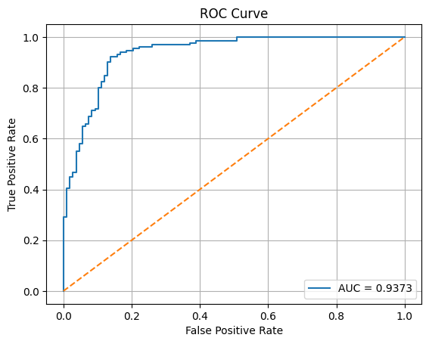
Fig. 2. ROC Curve of Image Model

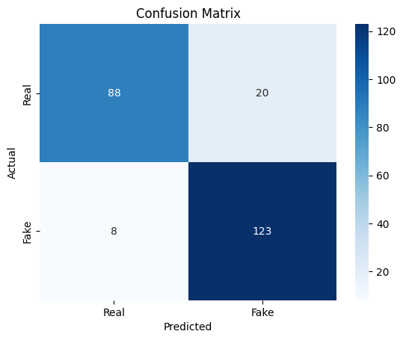
Fig. 3. Confusion Matrix of Image Model

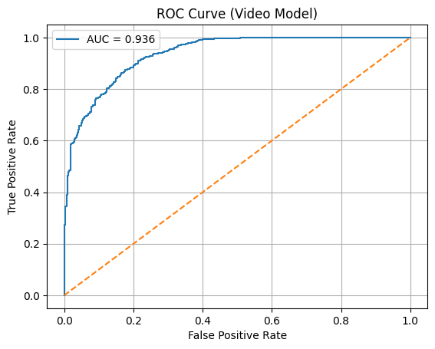
Fig. 4. ROC Curve of Video Model

Conclusion
This paper introduces a deep learning based approach to detect deepfake content in both images and videos using EfficientNet along with frame aggregation techniques. The model delivers strong performance with high accuracy and shows good ability to generalize across different types of data. The proposed model has practical applications in areas such as media verification, cybersecurity, and digital forensics. In the future, the model can be further enhanced by integrating temporal models like LSTM to better capture patterns across video frames and improve overall detection performance.

References
- H. Kim, “Novel deep learning-based facial forgery detection for effective biometric recognition,” Applied Sciences, vol. 15, no. 7, pp. 3613, 2025.
- M. Alrashoud, “Deepfake video detection methods, approaches, and challenges,” Alexandria Engineering Journal, vol. 79, no. 1, pp. 1–25, 2024.
- L. Y. Gong and X. J. Li, “A contemporary survey on deepfake detection: Datasets, algorithms, and challenges,” Electronics, vol. 13, no. 3, pp. 585, 2024.
- Q. Lv et al., “DomainForensics: Exposing face forgery across domains via bi-directional adaptation,” IEEE Transactions on Information Forensics and Security, vol. 19, pp. 7275–7290, 2024.
- A. Kaur et al., “Deepfake video detection: Challenges and opportunities,” Artificial Intelligence Review, vol. 57, 2024.
- Y. Zhou and S. Lim, “Joint audio-visual deepfake detection,” ICCV, 2021.
- Z. Zhao et al., “Multi-attentional deepfake detection,” CVPR, 2021.
- H. Khalid et al., “FakeAVCeleb: A novel audio-video multimodal deepfake dataset,” NeurIPS, 2021.
- B. Dolhansky et al., “The Deepfake Detection Challenge dataset,” arXiv, 2020.
- T. Karras et al., “Analyzing and improving the image quality of StyleGAN,” CVPR, 2020.
- J. Frank et al., “Leveraging frequency analysis for deepfake detection,” ICML, 2020.
- J. Wang et al., “CNN-generated images are surprisingly easy to spot,” CVPR, 2020.
- L. Dang et al., “On the detection of digital face manipulation,” CVPR, 2020.
- S. Verdoliva, “Media forensics and deepfake detection: A survey,” IEEE JSTSP, 2020.
- S. Agarwal et al., “Detecting deep-fake videos from appearance and behavior,” IEEE WIFS, 2019.
- H. Nguyen et al., “Multi-task learning for detecting manipulated facial images,” IEEE BTAS, 2019.
- Y. Li and S. Lyu, “Exposing deepfake videos by detecting face warping artifacts,” CVPR Workshops, 2019.
- M. Tan and Q. Le, “EfficientNet: Rethinking model scaling for CNNs,” ICML, 2019.
- A. Rossler et al., “FaceForensics++,” ICCV, 2019.
- I. Amerini et al., “Deepfake video detection through optical flow analysis,” ICIP, 2019.
- X. Yang et al., “Exposing deep fakes using inconsistent head poses,” ICASSP, 2019.
- S. McCloskey and M. Albright, “Detecting GAN-generated imagery,” ICIP, 2019.
- T. Nguyen et al., “Capsule-forensics,” ICASSP, 2019.
- D. Güera and E. J. Delp, “Deepfake video detection using RNNs,” IEEE AVSS, 2018.
- P. Korshunov and S. Marcel, “Deepfakes: A new threat,” IEEE FG, 2018.
- G. Huang et al., “DenseNet,” CVPR, 2017.
- F. Chollet, “Xception,” CVPR, 2017.
- K. He et al., “ResNet,” CVPR, 2016.
- J. Redmon et al., “YOLO,” CVPR, 2016.
- O. Ronneberger et al., “U-Net,” MICCAI, 2015.

